Calculations with null values

- IsNull() Function
Select ename,sal,comm, sal+comm From emp

IsNull is a SS proprietory function which takes two parameter.
select ename,sal,comm, sal + IsNull(comm,0) “Take Home” from emp;

- Coalesce Function

It returns the first not null value amongst the given values.

Example 1:

select ename, sal, comm, sal + coalesce(comm,0) as "Total"
from emp

To get the first not null value for each row: (Suitable for more than 2 arguments)

Example 2:
Drop Table Identification;

create table Identification
(empid Integer,
ename varchar(30) NOT NULL,
passport_number char(15) ,
license_number char(15) ,
pan char(15) ,
credit_card_number char(15) ,
account_number char(15)
);

insert into identification values(1,'John',null,null,'PN-78654','CC-12345','AN-3456');
insert into identification values(2,'Martin','PS-566774',null,null,null,null);
insert into identification values(3,'Smith',null,null,null,null,null);
insert into identification values(4,'Roger',null,null,null,null,'AN-9876');
insert into identification values(5,'King',null,null,null,'CC-8787','AN-9878');

select * from identification;

select empid,ename, coalesce(passport_number, license_number,pan,credit_card_number,account_number,'INVALID') "FOUND" from identification;

- NullIf
Compares two expressions and returns null if they are equal, if they are not equal then returns the first expression.

Demo:
Use SS
Go

select nullif('A','A')
go

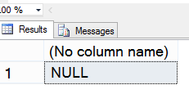

select nullif('A','a') -- Default case insensitive
go

select nullif('A','B')
go

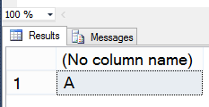

select nullif('A',Null)
go

First argument to NULLIF cannot be the NULL constant because the type of the first argument has to be known.

select nullif(Null,'A')
go



Project specific example:

create table cust_credit_details
(custid char(3),
custname varchar(20),
credit_used integer,
total_approved integer,
check(credit_used <= total_approved));

Let us add 4 rows in this table.For Martin & King the credit used & total approved is same.

Insert Into cust_credit_details Values('C1','John', 5000, 7000);
Insert Into cust_credit_details Values('C2','Martin',4000,4000);
Insert Into cust_credit_details Values('C3','Smith',3500,4000);
Insert Into cust_credit_details Values('C4','King',20000,20000);
go

select * from cust_credit_details
go

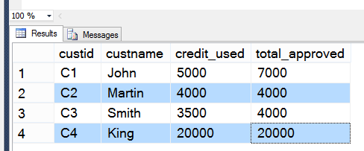

select custid,custname, credit_used, total_approved,
nullif(TOTAL_APPROVED,CREDIT_USED) "NullIf"
from cust_credit_details;

Note in the above nullif function the TOTAL_APPROVED column is taken first & then CREDIT_USED is taken because there is a possibility of no credit used. And if first parameter itself is null then it will throw error

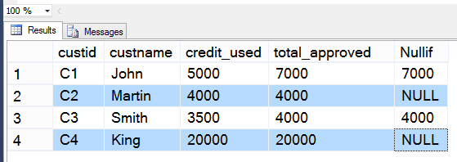

Generating a report of credit status

select custid, custname, credit_used, total_approved,
case
when nullif(TOTAL_APPROVED,CREDIT_USED) is NULL
then 'There is no credit balance available'
else
Cast((total_approved-credit_used) as varchar) + ' credit available'
end "Status"
from cust_credit_details;

